The Shadan Degree College for Women

**Graduation Project**

PROJECT NAME:

BUCKET-LIST

PROJECT TEAM

Amreen Begum 118120468001

Pooja Rani 118120468003

Farha Fathima 118120474003

Ayesha Fathima 118120474002

UNDER THE GUIDANCE OF: HEAD OF DEPARTMENT:

Mrs. Yasmeen Fathima Mrs. Shabana Parveen

**ACKNOWLEDGEMENT**

There are many people who helped us, directly or indirectly to complete our project successfully and we would like to express our special thanks of gratitude to ***Ms. Yasmeen Fatima*** [Asst. Prof.]

and  ***Ms. Parveen* (Head of the computer science department)** for the time and effort they provided throughout the year.  Your useful advice and suggestions were really helpful to us during the project’s completion. In this aspect, we are eternally grateful to you.

We express our sincere thanks to our principal mam ***Ms. Naseema Akhter*** for providing the lab facility to complete the project.

Finally, we would like to thank all our family and friends for their help and constant cooperation during our project period.

***INDEX***

**Topic**

1. INTRODUCTION

    1.1 MOTIVATION

     1.2 purpose

     1.3 scope

1. Literature survey

   2.1 literature review

   2.2 waiting time

1. Methodology

   3.1 justification of Methodology

   3.2 description of the Methodology

4. analysis and data model with e-r diagram

5. result

     5.1 front end

     5.2 backend

6. conclusion

**List of Figures**

ABSTRACT

A Bucket List is a number of experiences or achievements that a person hopes to have or accomplish during their lifetime. A list of things that a person would like to do or achieve before they regret it. The idea behind creating a bucket list of things you hope to do before time passed. Creating a bucket list can benefit us in several ways like getting in touch with values, remembering our goals, getting creative, and keeping track of peak experiences, etc. Creating a list of various students like backbenches, cheaters, and toppers in detail. Unlike school life, college life has a different experience and a person needs to have this experience in their life. Undergraduate students must enjoy their college life which is remarkable and precious for them. The problem faced by the students like social anxiety, family expectations, depression, lack of motivation, and low self-esteem. To overcome these issues we all should get comfortable with public speaking, make friends, and discover a new culture that may help everyone to travel easily and ticks the box. Instead of just focusing on studying, a person must participate in other activities and socialize as much as possible in his or her life. As all of these things teach all of us to build our confidence to face the challenges and struggles in our future.

INTRODUCTION

A bucket list is a list of experiences that someone wants to have at some point in their life. They’re a fun method of life planning that can include professional and personal goals or anything else that you can imagine A bucket list reflects your values and desires a number of achievements that a person hopes to have or accomplish during their lifetime. Creating a bucket list will focus your interest and provide structure and motivate you to step out of the box. It can expand your mind to new possibilities and make your dreams become a reality. Often a bucket list of big accomplishments to travel and to do fun things we would like to experience in our lives. It gives positive activities which are good for our well-being. It also includes simpler pleasures or less extravagant things we want to do. to have a well-rounded life full of happiness and contentment. The most important reason for having a bucket list is to ultimately achieve your goals.

It’s the main reason for having this list in the first place. With this, you set your goals and you plan out a way towards attaining them. To live a meaningful or memorable life doesn’t mean that you did everything you wanted to do. Even achieving a small short-term goal will give you a sense of satisfaction. That feeling alone is your initial reward for your achievement.

On the other hand, even if you don’t achieve everything on your list, you are sure that you have at least some great memories because you attained some of them.

OBJECTIVE

AIM OF THE PROJECT :

  The aim of the project is to Focus to live a life with hopes and aspirations. Making a bucket list allows us to reflect on our values and goals, and identify important milestones and experiences that we want to have in our lifetime.

​Data visualization is also used to represent output in the form of images and charts​

*SCOPE OF THE PROJECT*:

The scope of the project is to Create a bucket list that will focus your interest and provide structure and motivate you to step out of the box. It can expand your mind to new possibilities and make your dreams become a reality. Those memories will be the basis of a life that is meaningful, not for others, but for yourself. Always remember, acquiring memories is always better than chasing material possessions.

*JUSTIFICATION OF STUDY OBJECTIVE*

It’s important to take time for things you enjoy in life—doing things you enjoy can make you feel energized and more relaxed at the same time, and help to keep [burnout](https://www.verywellmind.com/stress-and-burnout-symptoms-and-causes-3144516) at bay. Traditional [vacations bring important benefits](https://www.verywellmind.com/take-vacations-for-stress-relief-overall-health-3145274) for stress management and life satisfaction, but for those who can’t spare the time or expense for a week-long trip, "[staycations](https://www.verywellmind.com/why-you-should-take-a-break-3144576)" are a viable alternative.

Fitting more [hobbies](https://www.verywellmind.com/the-importance-of-hobbies-for-stress-relief-3144574) and fun into your lifestyle can bring a significant payoff as well. One fun and effective strategy for ensuring that you take the time you need for the "more fun things" in life (as well as some important goals you may have) is to create a "bucket list"—or several.

The idea behind a bucket list is, as they state in the movie with the same title, to create a list of things you hope to do before you "kick the bucket." But you can also use the idea for any deadline—say, a list of things you wish to do before you enter your next decade of life, or before the summer ends. Creating a bucket list can benefit you in several ways.

*Literacy*

*survey*

The survey is a research method used for collecting data from a predefined group of respondents to gain information and insights into various topics of interest we all conducted our survey related to our bucket- list in the Google form as we can see in the above figures as we asked the students about pursuing their dreams in Fig1 we can see that stay focused and motivated and don’t let fear to stop them has increased among all it means that it really helps a number of students to pursue their dreams. In Fig 2 88.9 %number of students spend their time while their studying. Most students enjoy their college life by bunking classes and using their mobiles as we can see in our pie chart Fig 3. and in fig4 According to the students, the definition of stud student who can learn new things in their life. However, with the arrival of new technologies, it is common to distribute them using digital media such as social networks emails, etc.

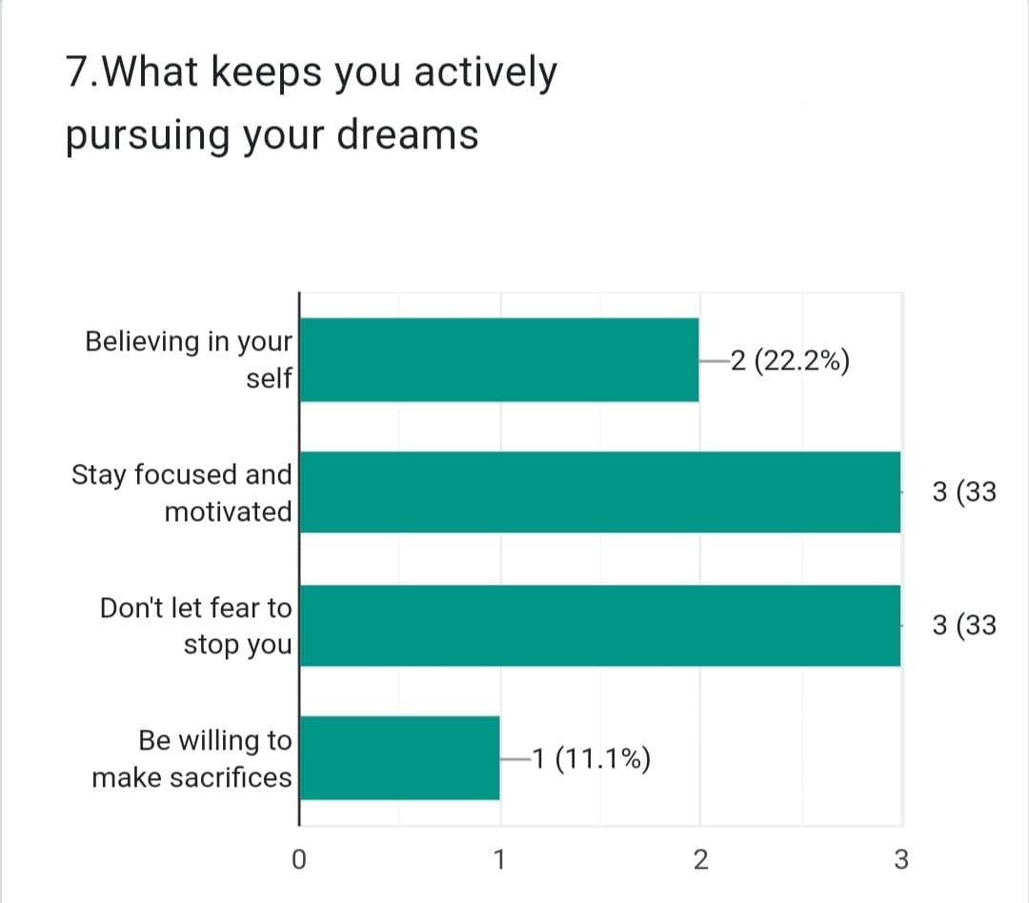

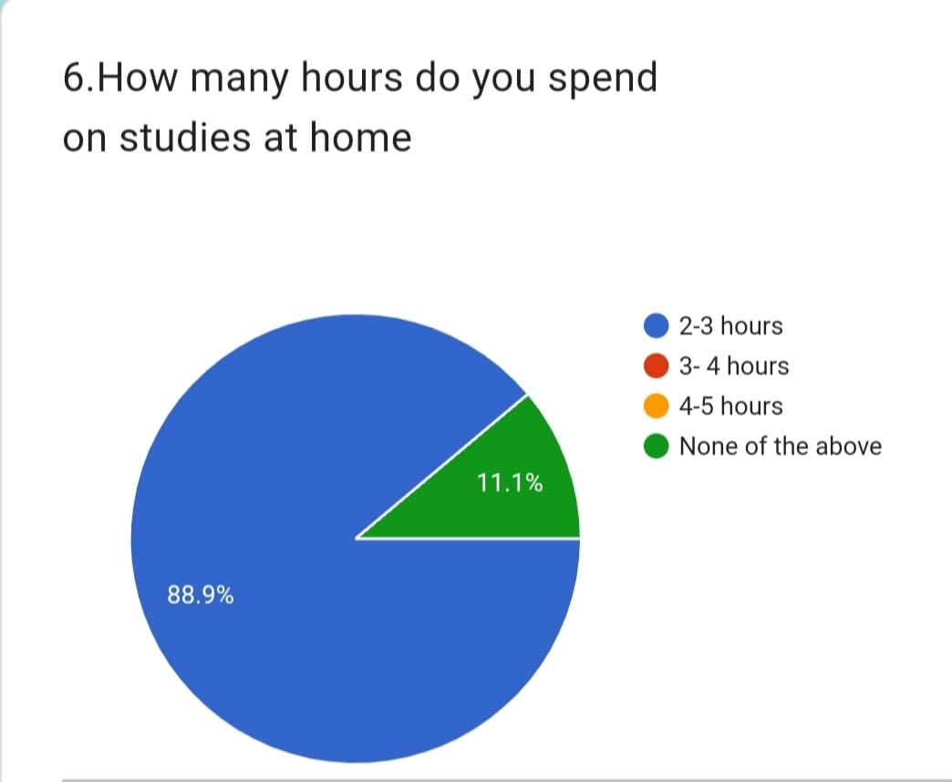

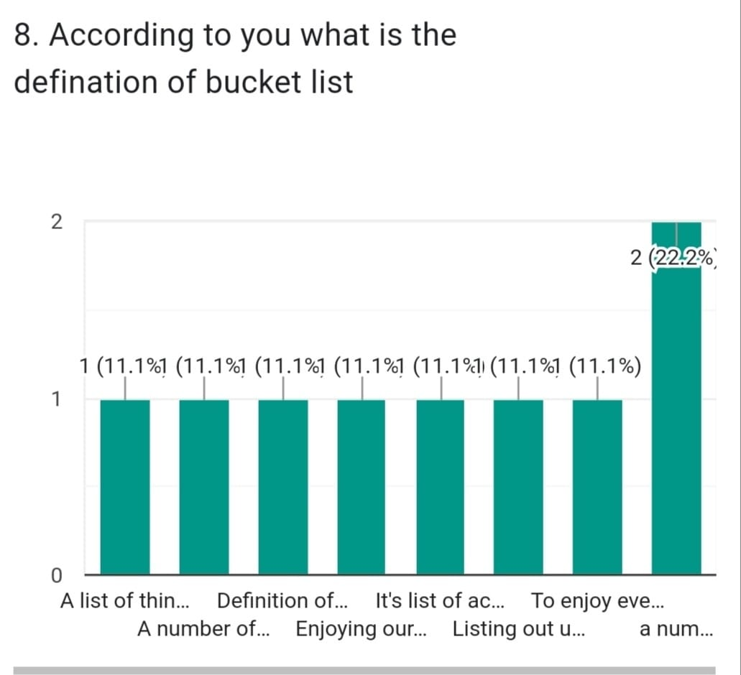

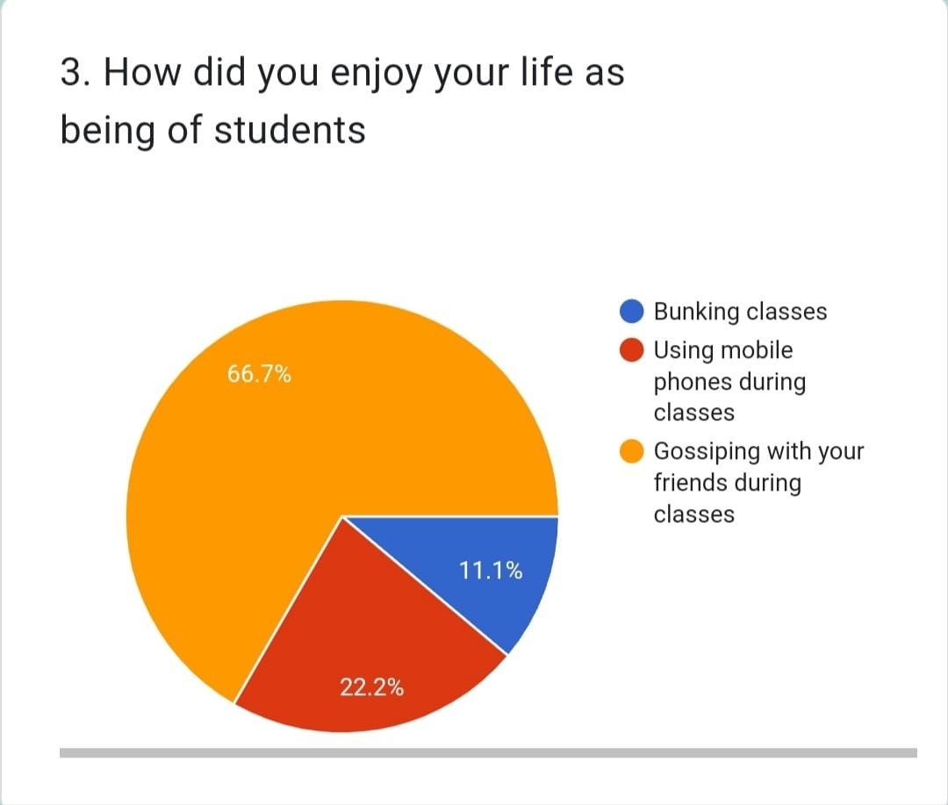

Four days of time has been taken to conduct and prepare the survey report on BUCKET-LIST.

*METHODOLOGY*

Creating a bucket list of places you want to go or things you want to do can be a very helpful tool towards attaining your life goals. Having one gives you a master list of things you want to do before your time in this world ends. It’s like foreseeing what you want in the future and putting it on one list. Making your own bucket list allows you to sort of plan out goals in a step-by-step process. It also gives you the ability to break down your goals into smaller and more doable activities. When you have a bucket list, you already know the things you want and need to do. You automatically eliminate the time you spend thinking and remembering them, thus you become more efficient. Additionally, when you have a bucket list, you break down your goals into doable activities, which makes it easier and faster for you to achieve your goals.

Moreover, having a bucket list will give you a fresh view of things that you want to do. Consequently, this will force you to do them as fast as you can. It also allows you to sharpen your focus and get you back on track, if you have derailed in any way. In connection with the above reasons, having a bucket list would basically improve your life. It can be considered a life improvement when you don’t forget about things anymore or you have a sense of purpose. Although it would not be very quick, having a bucket list would affect your life for the better.

In a way, you will slowly improve how you run your life starting with your time management. Too many people waste their precious time on irrelevant things, which in the end have a neutral or negative effect on their entire life. Improving your life now will only make things better in the long run.

**Benefits OF Bucket- List**

Creating a bucket list not only gives you a sense of clarity regarding your desires but also gives you a sense of achievement when you accomplish each item. Some of the benefits -

* It gets you excited, and motivated – pushes you to go accomplish your goals
* It helps you focus on things, which are important to you – It surfaces the things which you truly desire, instead of the things which you are ‘supposed to do
* Pushes the boundaries of your comfort zone – we miss out on so many things because of being in our comfort zone, get out of it and you will see a new world of infinite possibilities
* Makes you more interesting – You have clues to start a conversation. The confidence shows in your voice when you have experiences of fulfilling and sharing your views
* Might make you fitter and livelier - if you have some adventure activities on your list like marathons, skydives, etc.
* It helps you dream big and achieve big – There are absolutely no boundaries on what you can think of doing, hence it helps you open up to newer possibilities.

## **Getting in Touch With Your Values**

When you make a list of all the things you’d like to do, this activity may be a springboard to becoming more aware of what’s really important to you. When you start thinking about what you really want to do, you can find perspective on how you are currently spending your time, and on what you’d like to be doing.

The tie and energy for things that really matter to you aren’t eaten up by the time you put into the things that matter less. Making a bucket list can help you remember what you value the most.

## **Remembering Your Goals**

When we feel we have lots of time ahead of us—a new summer, a new year, a whole lifetime—we may think about what we’d like to do with it. Then, “real life” takes over, and we may focus more on our day-to-day goals and less on our goals for fun, excitement, stress relief, or on our long-term goals.

Creating a bucket list can keep us in touch with these goals we have and can help us keep track of them as we plan them into our lives and check them off upon completion.

## **Getting Creative**

Nothing gets creative juices flowing like a good brainstorming session. Creating a bucket list can help you tap into the creative part of you that dreams bigger, nurtures your inner child, and makes life more worthwhile. Once you’ve put your creative side into play by creating the bucket list, your everyday self can stay inspired to put those dreams and plans into action.

## **Enjoying Life**

Simply creating the list can be fun. Sharing your list with others, revisiting your list over time, and checking off your experiences as you collect them, can all be ways to enjoy life more, and share the fun.

## **Keeping Track of Peak Experiences**

Creating a bucket list can be inspirational. While you may not complete every item on your list, you will likely complete some, and get more out of your life than if you hadn’t created the list. These are the experiences you may remember the most in life, that may change who you are in a positive way.

However you use your bucket lists, they can be a positive experience that can be utilized to fit your needs. Creating a bucket list can also relieve stress and enhance your life.

### FORCES YOU TO LOOK AT WHAT YOU REALLY WANT

Many people will live their entire lives without having any idea as to what they really want. They will follow society’s conventional expectations of getting married, working the same office job for the next twenty years, buying a home and having children ­– all without giving it a second thought because that is just what they are “supposed to do”. But, if that path is not their true passion then life will end up leading them, instead of them leading their life.

### 2. GETS YOU EXCITED

Many people’s sleepless nights are the effects from having a mind filled with countless tasks for the next day. But, what if what kept you up at night were thoughts of planning your dream vacation to spend the night at a Bedouin camp or going back to school to study your true passion—French viticulture? Then being awake would be because of excitement, a reason to get up early in the morning and stay up late at night.

When you are stuck in the rut of day-to-day life, it can be difficult to get excited about the day that lies ahead. A  gives you a reason to spend that extra hour a day working, putting meaning behind the extra effort because the additional money will be why your dream of ice climbing in Iceland will come true. It can create excitement deep in your soul and exposes the passion you thought you had lost many years ago.

### 3.CREATES FOCUS

Another benefit of a bucket list is that it will give you a sense of direction that allow your mind to focus on the target, instead of getting sidetracked dawdling on social media or watching reruns of the Kardashians (I am admittedly guilty of that sometimes too!). It will help you determine your end goal and the steps that need to be taken to get there, keeping your eye on the prize.

For example, without a clear career focus, you may just take every promotion opportunity given, switching departments and ending up as the executive production manager, when what you really wanted was to be a marketing director.

Without clear goals it’s easy to get diverted, heading in multiple directions and years later ending up in a place you really never intended. Even with goals, if you cannot remain focused you will lose momentum, which will lead to a loss of motivation and ultimately failure to achieve the result you desire. But with it, you will be able to continuously refer to it in order to re-energize your focus.

### 4.MOTIVATES YOU

Without motivation, your dream will be nothing more than that; it is the necessary energy that pushes you to accomplish your goals. Motivation is why race car drivers win trophies, and business owners become millionaires, and it is the main reason that this is In order to truly get motivated you need to know what you really want, and writing a bucket list will help to determine exactly what that is. These goals will then be the root of your motivation. Also, having any sort of list naturally inspires you to want to cross things off of it, whether it is simply your weekly grocery-shopping list, daily to-dos, or bucket -list.

### 5.PUSHES THE BOUNDARIES OF YOUR COMFORT ZONE

It has been said that life begins at the end of your comfort zone, so then why are so many afraid of stepping outside of it? I will tell you why. Being inside your comfort zone minimizes stress and risk, keeping you at a low anxiety level. This makes it very easy to never push the boundaries because it’s pretty darn comfy inside the safety of your little bubble.

Everyday activities like taking a shower, cooking dinner, and going to work don’t create any apprehension because they are familiar. Whereas flying across the world, eating, and not speaking the language of an area will undoubtedly cause trepidation.

**Things To Do Before time passed**

1. Travel all around the world
2. Try a profession in a different field
3. Do an extreme sport
4. Pursue your passion
5. Do volunteer work
6. Getting in touch with your values
7. Keep track of peak experiences
8. Make a college scrapbook for every year
9. Join a study group
10. Go to the college party
11. Get comfortable with public speaking
12. Enroll in random classes
13. Explore your entire campus
14. Organize a road trip with your college friends
15. Find a subject you are passionate about

If you don’t live your days by goals and plans, chances are that you spend most of your time caught in a flurry of day-to-day activities. Ever felt that your days are passing you by without any tangible output? What did you accomplish in the past month? What are your goals for the next three months? Look at the things that you have been doing and the things that you’re planning to do next — do they mean anything to you if you are to die today? Having a bucket list reminds you of what’s really important to you so that you can act on them.

Even if you live by goals or to-do lists, they are probably framed within a social context, e.g. performance, career, and health. A bucket list opens up the context for your life. It’s a list to identify everything you’ve ever wanted to do, whether it’s big or small, purposeful or random.

It’s just like planning all the highlights for YOUR life. Even though I already set goals by default, I still found many new things to do while writing on my own list. It was an incredibly insightful exercise. What’s more, coming up with my list gave me new-found enthusiasm knowing what I have planned ahead for my life!

The objective of creating this list isn’t to create some fear-based mentality toward death. I don’t see our existence to be limited to our physical years on Earth — our physical lifespan is but a short speck of our existence in the universe. The whole point of creating a bucket list is to maximize every moment of our existence and live our life to the fullest. It’s a reminder of all the things we want to achieve in our time on Earth so that instead of spending our time on pointless things, we direct it toward things that matter to us.

**Time complexity and space complexity**

The time complexity in Bucket Sort largely depends upon the size of the bucket list and also the range over which the elements in the array/list have been distributed. For example, if the elements in the array don't have a significant mathematical difference between them, it could result in most of the elements being stored in the same bucket, which would significantly increase the complexity   
Consider the following snippet from the algorithm Let us suppose that there are a total of K different buckets, so the outermost loop will take at least **o(k)** time. The inner loop will take at least **o(n**) time overall since there is a total of n elements distributed across the bucket list. Hence we can conclude that the overall complexity of the bucket sort will be **o(n+k) best case:o(n+n)=o(n).**

**The space complexity for Bucket sort is O(n + k), where n is the number of elements and k is the number of buckets.**

**Hence, the space complexity of this algorithm gets worse with the increase in the size of the input array and the bucket list as well.**

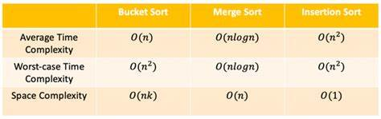

Bucket-Sort Algorithm

Bucket sort, also known as bin sort, is a sorting algorithm that divides an array’s elements

into several buckets. The buckets are then sorted one at a time, either using a different sorting

algorithm or by recursively

applying the bucket sorting algorithm.

The bucket sort method is as follows:

* Create an array of "buckets" that are initially empty
* Scatter: Go through the original array, placing each object in its appropriate bucket
* Each non-empty bucket should be sorted
* Gather. Return all elements to the original array after visiting the buckets in order

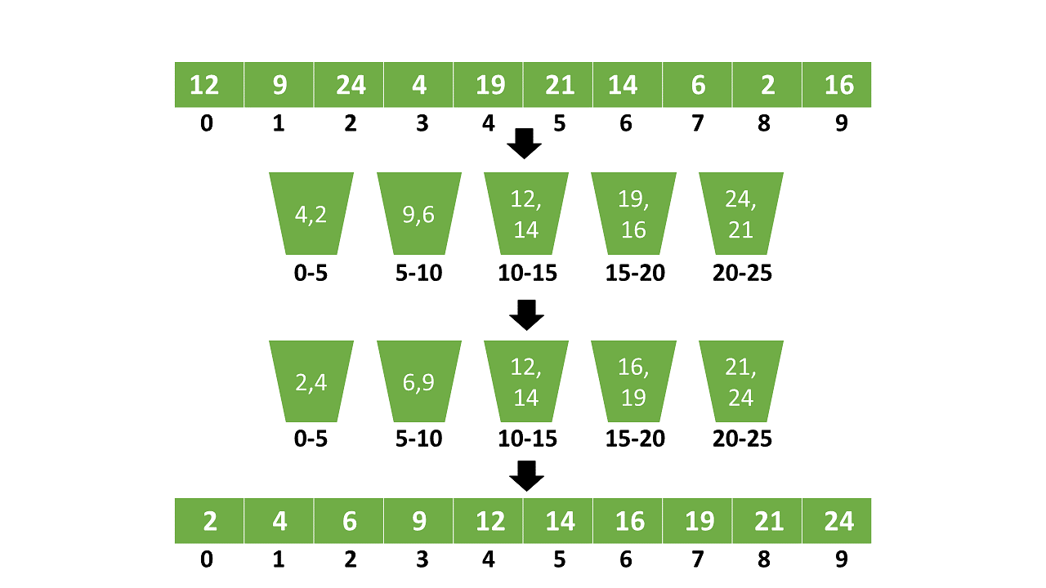

* Gather: Return all elements to the original array after visiting the buckets in order

*ANALYSIS, DESIGN AND*

*DEVELOPMENT*

*FRONT END*

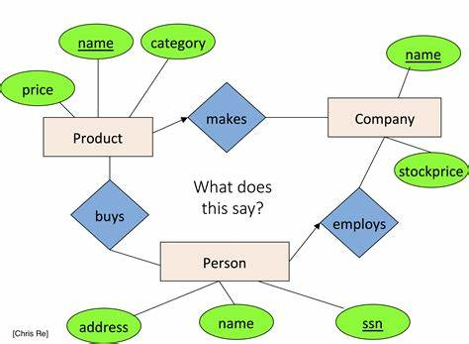

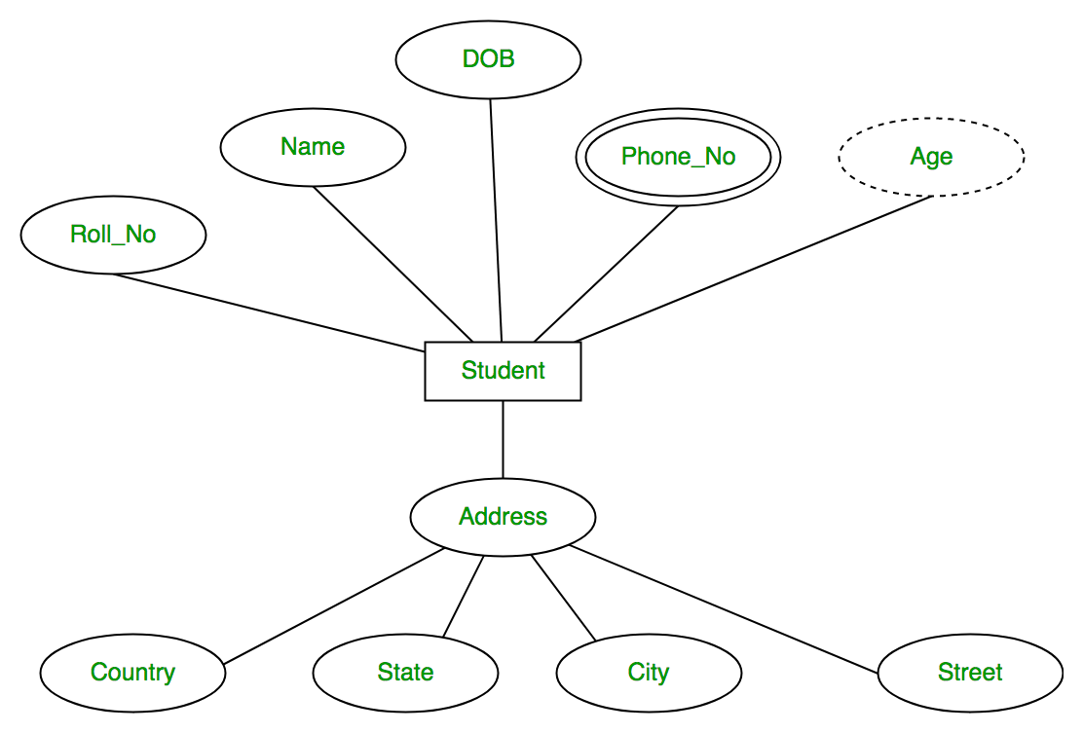

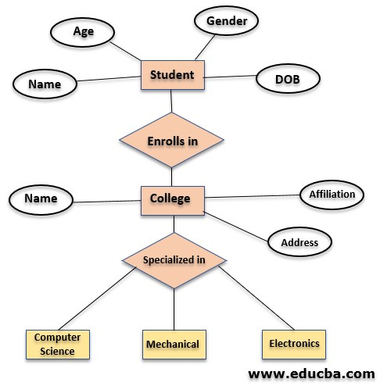

**RESULT**

**FRONT END AND BACKEND**



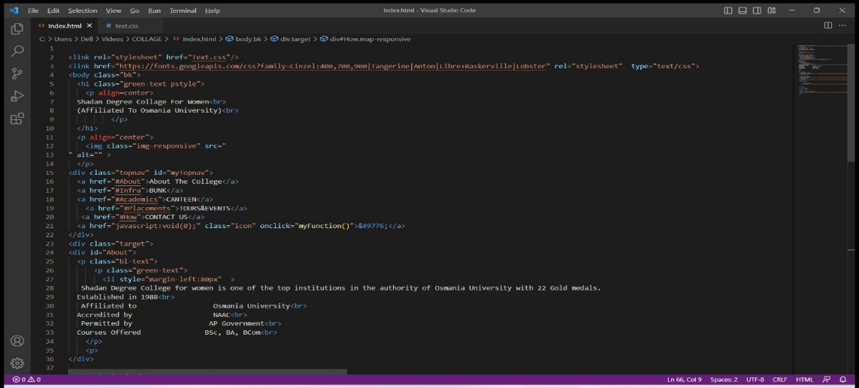

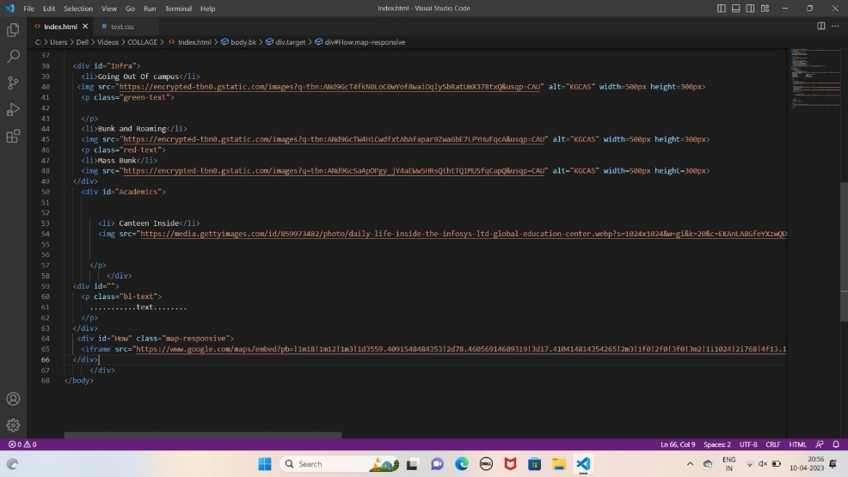

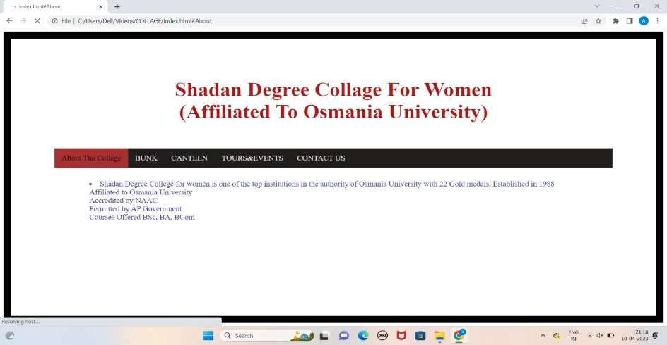



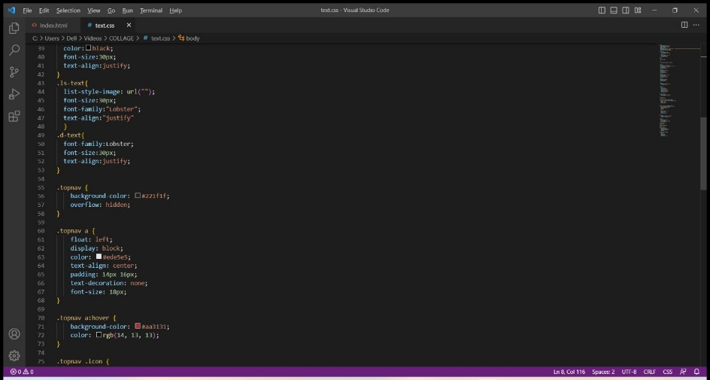

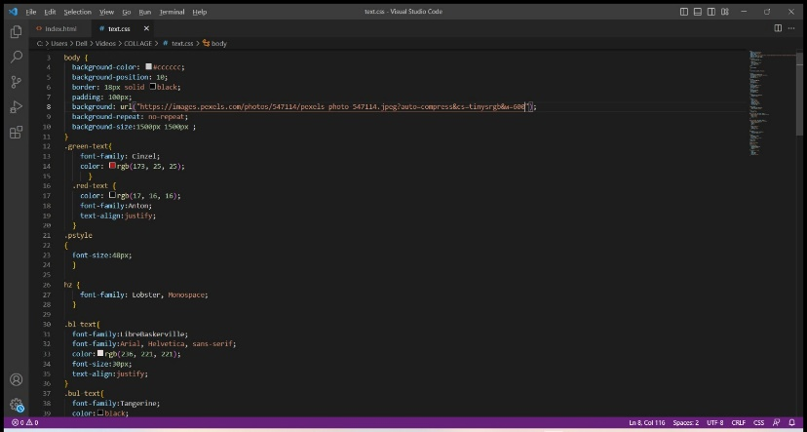

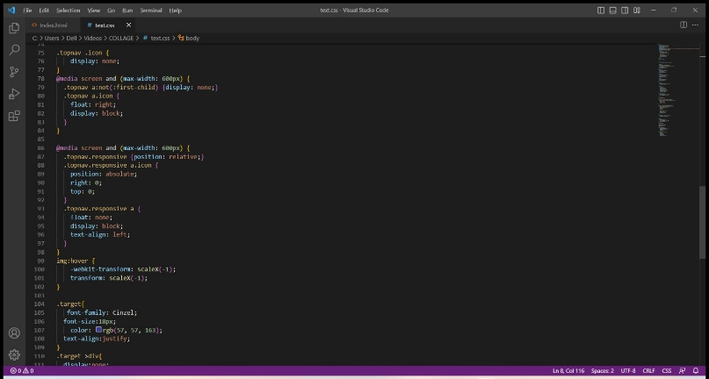



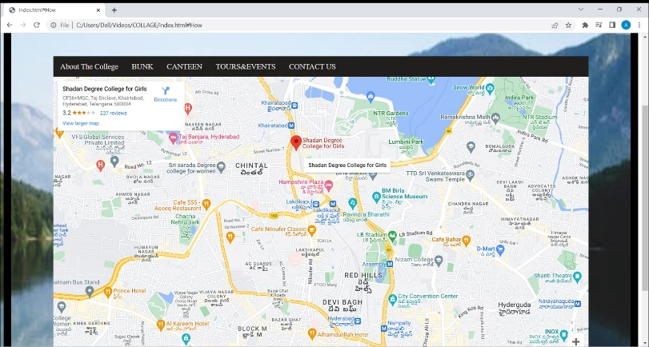

## **Conclusion**

Over the past semester I have learned a lot about my bucket list items and about myself. As I have researched and written about my individual bucket list items, I have obviously become more knowledgeable about the topics, however, I was not expecting the bucket list to help me better understand my own personality.  
  
Since I have written about some of my bucket list items, I have realized that they are related to my personality. For example, I have noticed that as I learn more about a subject I become less and less fearful of it. I have also learned that I love pushing my own boundaries and that explains why I am outgoing and enjoy talking to others. In addition, I have learned that I always try to see myself in others’ shoes and ask myself; what would I do?  
  
Another thing that I have learned more about is Ethos, Logos, and Pathos rhetoric. To be honest, I found the multi-genre project much more difficult when I had to apply one of the three modes of persuasion to it. Though difficult, I have noticed that my understanding of the modes of persuasion has grown. As a business major, I recognize the importance of understanding and being able to apply the modes of persuasion. I believe this is why it was my favorite part of the project. I always enjoy projects that are different and allow me to create and show something off. In fact, I made a point to try forms of genres that I have never used before, so I could learn something new.  
  
In the end, I was surprised to see how much one can learn from their own bucket list. I never took the time to think through the things I would like to do before I die and I never thought it could reveal something about my personality that I did not already know. Though this project seemed tedious at times, I am extremely that we did.